Computer Architecture Lab
(EL-2012)
LABORATORY REPORT

Fall 2026

(Lab#03)
Apply Behavioral-level Verilog to Design and
Simulate Combinational Modules

Student Name: Huzaifa Kashif Roll No: 24I-6501 Section: CE-A

Date performed: 6th September, 2026

MARKS AWARDED: ________ / 10

Signature and date of Instructor: _________________
Lab Instructors: Dr. Nasir Ali Shah, Engr. Fasih Ahmad

______________________________________________________________________________________________________________________________________________________

NATIONAL UNIVERSITY OF COMPUTER AND EMERGING SCIENCES, ISLAMABAD
Prepared by: | Fasih Ahmad |  | Version: 1.0
Verified by: | Dr. Nasir Ali Shah |  | Updated: Fall 2026

Task 1:

Description:
Here I utilized the same concept for creating a full adder as I did in the last lab. Except here, I had a control variable which would be XORed with each B bit and would give the complement, thus acting like subtraction. Then each of the 4 bits is added.

Code:
module ha1(sum,carry,a,b);
input a;
input b;
output sum;
output carry;
assign sum = a^b;
assign carry = a & b;
endmodule

module ha2(sum,carry,a,b);
input a;
input b;
output sum;
output carry;
assign sum = a^b;
assign carry = a & b;
endmodule

module fa(SUM,COUT,a,b,cin);
input a; input b; input cin;
output SUM; output COUT;

wire s1;
wire c1;
wire c2;
ha1 half1(s1,c1,a,b);
ha2 half2(SUM,c2,s1,cin);
assign COUT = c1+c2;
endmodule

module addsub4(S,COUT,A,B,control);

input [3:0] A;
input [3:0] B;
input control;

output [3:0] S;
output COUT;

wire [3:0] BX;
wire c1;
wire c2;
wire c3;

assign BX[0] = B[0] ^ control;
assign BX[1] = B[1] ^ control;
assign BX[2] = B[2] ^ control;
assign BX[3] = B[3] ^ control;

fa FA0(S[0],c1,A[0],BX[0],control);
fa FA1(S[1],c2,A[1],BX[1],c1);
fa FA2(S[2],c3,A[2],BX[2],c2);
fa FA3(S[3],COUT,A[3],BX[3],c3);

endmodule

module testbench();

reg [3:0] A;
reg [3:0] B;
reg control;

wire [3:0] S;
wire COUT;

addsub4 uut(S,COUT,A,B,control);

initial
begin

control = 0;

A = 4'b0011;
B = 4'b0010;
#50;

A = 4'b0101;
B = 4'b0011;
#50;

A = 4'b0111;
B = 4'b0001;
#50;

control = 1;

A = 4'b0101;
B = 4'b0011;
#50;

A = 4'b1001;
B = 4'b0010;
#50;

A = 4'b0111;
B = 4'b0100;
#50;

end

endmodule

Output:
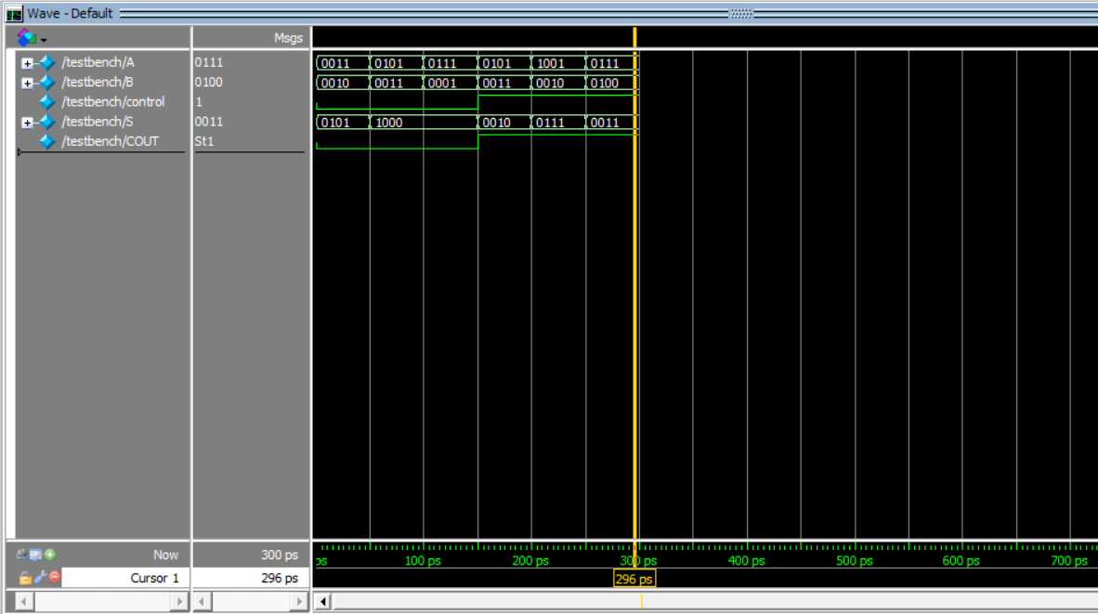

Task 2:

Description:
Here I again utilized the multiplexer logic used in the last lab. Here, however, I added an andAB and orAB that would ensure that it would be a 0 when A & B and 1 when A || B.

Code:
module multiplex(Y,A,B,Select);

input A,B,Select;
output Y;

wire notSelect;
wire w0,w1;
wire andAB;
wire orAB;

not(notSelect,Select);

and(andAB,A,B);
or(orAB,A,B);

and(w0,andAB,notSelect);
and(w1,orAB,Select);

or(Y,w0,w1);

endmodule

module testMult();

reg A,B,Select;
wire Y;

multiplex uut(Y,A,B,Select);

initial
begin

Select = 0; A = 0; B = 0;
#50 Select = 0; A = 0; B = 1;
#50 Select = 0; A = 1; B = 0;
#50 Select = 0; A = 1; B = 1;

#50 Select = 1; A = 0; B = 0;
#50 Select = 1; A = 0; B = 1;
#50 Select = 1; A = 1; B = 0;
#50 Select = 1; A = 1; B = 1;

end

endmodule

Output:
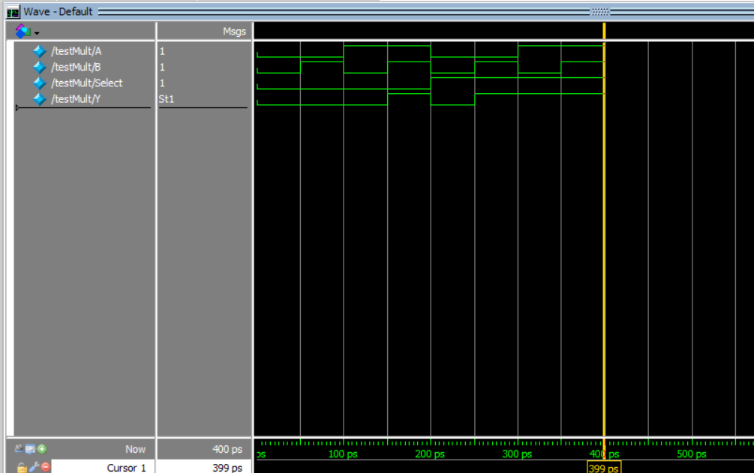

Task 3:

Description:
Here I initialized the input to be 2-bit numbers. Here I utilized the always block. This makes sure that when the inputs change, the always block always runs. The always block contains the if-else statements that assign the right bit values. So when the bit is larger, greater is 1; if equal the equal is 1; and if the bit is less, less is 1.

Code:
module comparator(A,B,equal,greater,less);

input [1:0] A;
input [1:0] B;

output equal;
output greater;
output less;

reg equal;
reg greater;
reg less;

always @(*)
begin

if (A == B)
begin
equal = 1;
greater = 0;
less = 0;
end

else if (A > B)
begin
equal = 0;
greater = 1;
less = 0;
end

else
begin
equal = 0;
greater = 0;
less = 1;
end

end

endmodule

module testComp();

reg [1:0] A;
reg [1:0] B;

wire equal;
wire greater;
wire less;

comparator uut(A,B,equal,greater,less);

initial
begin

A=2'b00; B=2'b00; #50;
A=2'b00; B=2'b01; #50;
A=2'b00; B=2'b10; #50;
A=2'b00; B=2'b11; #50;

A=2'b01; B=2'b00; #50;
A=2'b01; B=2'b01; #50;
A=2'b01; B=2'b10; #50;
A=2'b01; B=2'b11; #50;

A=2'b10; B=2'b00; #50;
A=2'b10; B=2'b01; #50;
A=2'b10; B=2'b10; #50;
A=2'b10; B=2'b11; #50;

A=2'b11; B=2'b00; #50;
A=2'b11; B=2'b01; #50;
A=2'b11; B=2'b10; #50;
A=2'b11; B=2'b11; #50;

end

endmodule

Output:
